BASAVESHWAR ENGINEERING COLLEGE (Autonomous),

BAGALKOTE-587102



Department of electronics and communications

Certificate

This is to certify that project entitled “**Convert a Number to Word**” a bonafied work of**, Mr.Shrinivas Dasar (2BA21EC097)**The report satisfies the academic requirements with respect to project work prescribed for 3th semester during the academic year 2022-2023. It is certified that all corrections/suggestions indicated assessment of the project have been satisfied.

PROJECT GUIDE : HEAD OF THE DEPARTMENT :

PROF.M.C.ARALIMARAD DR.SHRIDHAR KUNTOJI

SIGNATURE WITH DATE :

Program

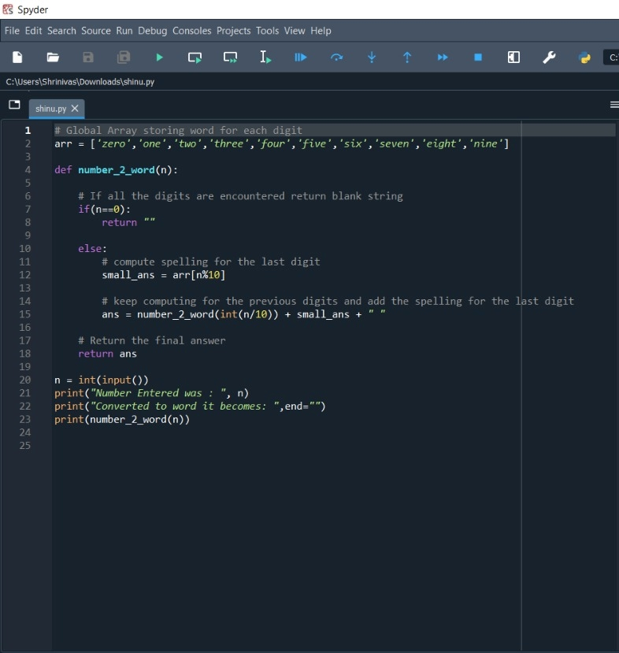

Output

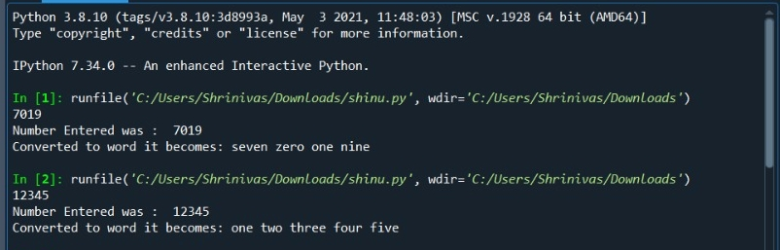

# Step 1: Creating a Global list for digit to word mapping

Create a global list containing wordings for each digit from 0 to 9. The list will contain elements mapped to the index as shown in the table below.

|  |  |  |  |  |  |  |  |  |  |  |
| --- | --- | --- | --- | --- | --- | --- | --- | --- | --- | --- |
|  | 0 | 1 | 2 | 3 | 4 | 5 | 6 | 7 | 8 | 9 |
|  | zero | one | two | three | four | five | six | seven | eight | nine |

Global list for digit to word mapping

|  |  |
| --- | --- |
| 1  2 | # Global Array storing word for each digit  arr **=** ['zero','one','two','three','four','five','six','seven','eight','nine'] |

# Step 2: Taking the input of the number and creating the main function

To take input of the number we will make use of input function and then typecast it to integer and also, we will create an empty function that will convert our number to words digit-wise.

|  |  |
| --- | --- |
| 1  2  3  4  5  6  7  8  9  10 | # Global Array storing word for each digit  arr **=** ['zero','one','two','three','four','five','six','seven','eight','nine']    **def** number_2_word(n):  **pass**    n **=** int(input())  print("Number Entered was : ", n)  print("Converted to word it becomes: ",end**=**"")  print(number_2_word(n)) |

# Step 3: Coding the Main Logic Inside the Function

For this code, we will be making use of **Recursion**. If you have very little or no knowledge about Recursion, I would recommend you to check out the tutorial mentioned below:

For every recursive call, we will check if my number became 0, if it did we would return an empty string otherwise we will keep adding the wordings for each digit with the help of the **modulus function**and divide the number **by 10** to shrink the number and move to the next digit.

The code implementation is shown below and comments are added for your understanding.

|  |  |
| --- | --- |
| 1  2  3  4  5  6  7  8  9  10  11  12  13  14  15  16  17  18  19  20  21  22  23 | # Global Array storing word for each digit  arr **=** ['zero','one','two','three','four','five','six','seven','eight','nine']    **def** number_2_word(n):        # If all the digits are encountered return blank string  **if**(n**==**0):  **return** ""    **else**:          # compute spelling for the last digit          small_ans **=** arr[n**%**10]            # keep computing for the previous digits and add the spelling for the last digit          ans **=** number_2_word(int(n**/**10)) **+** small_ans **+** " "        # Return the final answer  **return** ans    n **=** int(input())  print("Number Entered was : ", n)  print("Converted to word it becomes: ",end**=**"")  print(number_2_word(n)) |

**Outputs**:

|  |
| --- |
| Number Entered was:  123  Converted to word it becomes: one two three |
| Number Entered was:  46830  Converted to word it becomes: four six eight three zero |

## **Conclusion**

So by end of this program , we saw that the numbers can easily be converted to the wording (digit-wise) in a pretty easy and simple way by the use of Recursion.